Lab 3: Data Analysis and Statistical Operations using Numpy

Objective:
This assignment will help you practice the use of Numpy for basic data analysis and statistical computations, which are foundational for working with large datasets in business analytics.
Note: To get full credit on this assignment, you must use Numpy’s vectorized operations, ufuncs, and boolean/ indexing whenever applicable.

Part 1: Data Manipulation and Analysis
- Creating Arrays:
  - Create a 1D array of 100 random integers between 1 and 500.
  - Reshape the 1D array into a 10x10 matrix.
- Array Slicing and Indexing:
  - Extract all elements from the third column of the matrix.
  - Extract the submatrix consisting of rows 2 through 5 and columns 4 through 8.
- Filtering Data:
  - Find all elements in the matrix that are greater than 200.
  - Replace all elements in the matrix that are less than 100 with a value of 0.
- Basic Statistical Analysis:
  - Calculate the mean, median, standard deviation, and variance of the entire matrix.
  - Calculate the mean of each row and each column.
- Sorting:
  - Sort each row of the matrix in ascending order.
  - Sort the entire matrix by the values in the second column.

Part 2: Business Analytics Use Cases
- Power Consumption Analysis for Smart Grid Optimization: A smart grid system collects energy consumption data from multiple households in a city. The utility company wants to:
  - Estimate total monthly power consumption based on daily usage.
  - Compute power wastage by comparing usage to an efficiency threshold.
  - Adjust energy bills dynamically using tiered pricing:
    - Low usage (< 500 kWh) → Standard rate ($0.12 per kWh)
    - Medium usage (500-1000 kWh) → Slightly higher rate ($0.15 per kWh)
    - High usage (> 1000 kWh) → Premium rate ($0.20 per kWh)
  - Using NumPy's vectorized operations and ufuncs, help the company analyze and optimize power consumption by performing the above stated tasks.
  - Below is the simulated data:
# Simulated daily power usage (kWh) for different households (rows: households, cols: days)
daily_power_usage = np.array([
[15, 18, 20, 22, 25, 30, 28], # Household 1
[35, 38, 40, 45, 50, 48, 42], # Household 2
[8, 10, 12, 15, 10, 8, 9], # Household 3
[50, 55, 60, 65, 70, 75, 80] # Household 4 (High user)
])
- Sales Data Analysis: A company has sales data for 4 products over 12 months, represented by the following Numpy array:
sales_data = np.array([[200, 250, 300, 150], # Jan
[180, 220, 280, 140], # Feb
[220, 270, 310, 170], # Mar
[210, 260, 330, 160], # Apr
[230, 280, 320, 180], # May
[190, 240, 300, 150], # Jun
[210, 260, 310, 160], # Jul
[250, 290, 340, 190], # Aug
[220, 270, 310, 170], # Sep
[230, 280, 320, 180], # Oct
[240, 290, 330, 190], # Nov
[260, 300, 340, 200]]) # Dec
  - Find the total sales for each product over the year.
  - Find the month with the highest sales for each product.
  - Calculate the average sales per month across all products.
  - Find the product that has the highest average monthly sales.

Part 3: Linear Regression Using Numpy
- Linear Regression: You are given a dataset representing the sales of a product (y) based on the advertising budget (x). Use Numpy to calculate the best-fit line using the formula for linear regression:
$$y=mx+c$$
Advertising budget (x) and sales (y):
x = np.array([10, 20, 30, 40, 50, 60, 70, 80, 90, 100])
y = np.array([25, 45, 65, 80, 100, 130, 150, 180, 210, 240])
  - Given n datapoints, calculate the slope (m) and intercept (c) of the best-fit line using the least squares method (formulae below):
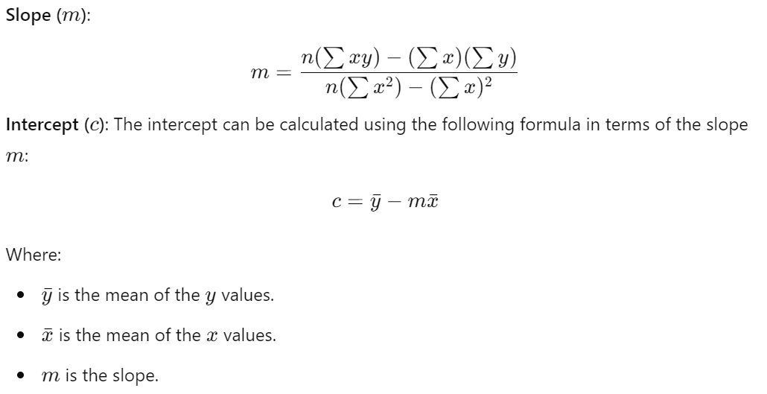

  - Predict the sales for an advertising budget of 120 using the computed values of m and c.
  - Calculate the mean squared error (MSE) of the regression model.
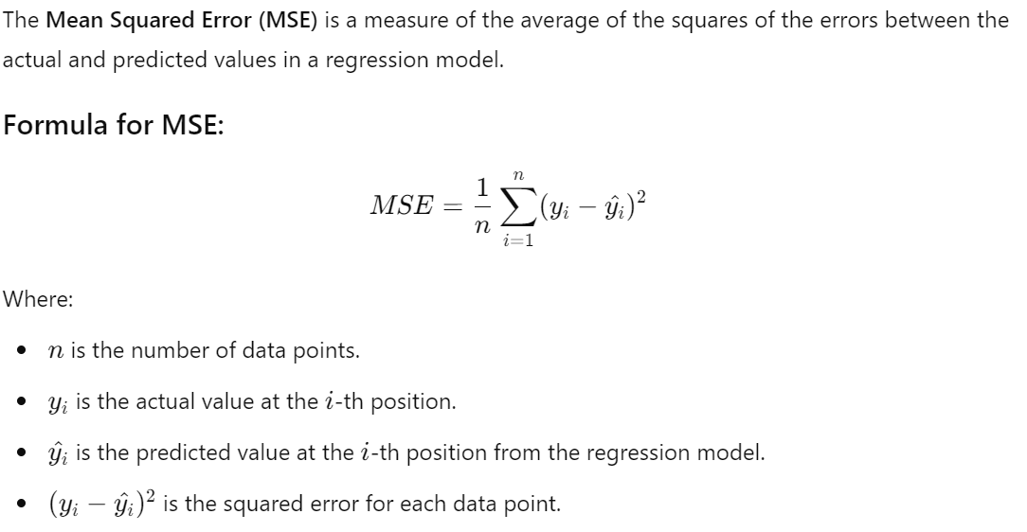

Deliverables:
- Submit a single Jupyter Notebook (.ipynb) with all the solutions.
- Include comments in the code explaining each part of your solution where needed.
- Ensure that your code runs without any errors before submission.

Grading Rubric:
- Correctness (50%): Does the code correctly solve each problem?
- Efficiency (25%): Does the code avoid unnecessary loops and make proper use of Numpy’s built-in functions?
- Edge Cases (10%): Does the code handle potential edge cases, such as empty arrays or matrices?
- Code Structure and Comments (10%): Is the code well-organized (e.g., proper use of functions) and are the comments clear and helpful?
- Style and Readability (5%): Is the code easy to read and does it follow good programming conventions (e.g., self-descriptive names for variables and functions)?

